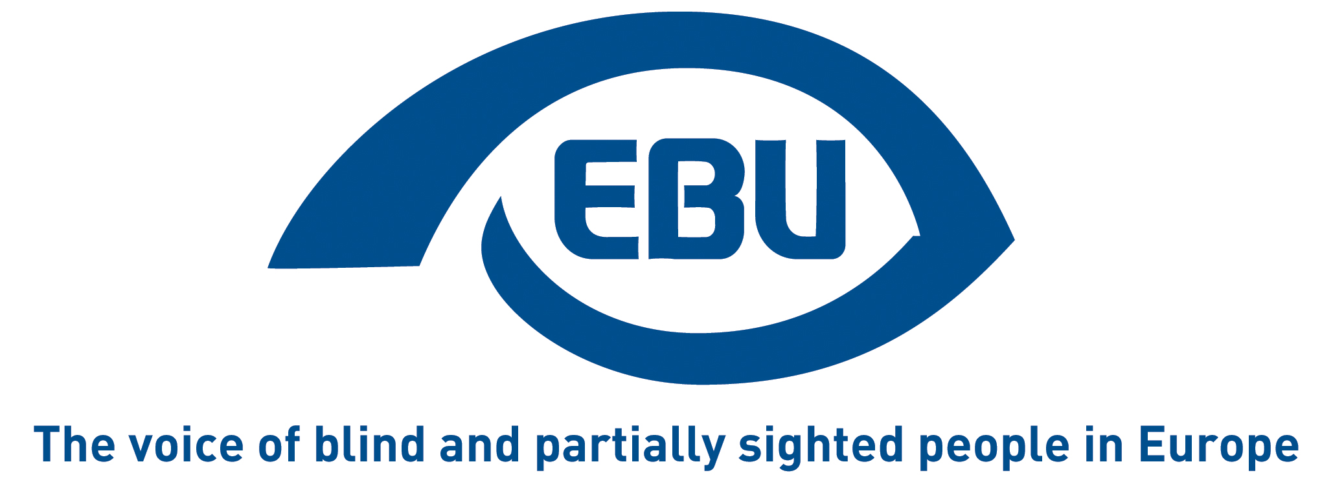
EBU training course on youth employability

19-21 May 2016
Tirrenia, Italy

Wednesday 18 May
Afternoon Arrival of participants
19:30 Dinner
21:00 – 22:00 Welcome and ice-breaking games (getting to know each other)

Thursday 19 May
09:00 – 10:15 Programme explanation, practical information and energizers/team building games
10:15 – 10:30 Break
10:30 – 12:30 Being aware of our personal and professional competences: reflection to identify our competences, knowledges and attitudes
12:30 – 14:30 Lunch break
14:30 – 16:00 Tips on how to prepare a good CV and motivation letter. Presentation of the Europass CV and, if time permits, of other Europass tools.
16:00 – 16.15 Break
16:15 – 18:00 Practical Exercise on cv/motivation letter
19:30 Dinner

Friday 20 May
09:00 – 10:15 How to prepare for a job interview
10:15 – 10:30 Break
10:30 – 12:30 Body language and presentational skills
12:30 – 14:30 Lunch break
14:30 – 16:30 Job interview in practice
16:30 – 16:45 Break
16:45 – 18:00 Stay active while waiting for a job: useful experiences to increase young people’s competences (civil service, European voluntary service, trainings, internships, etc): debate to share experiences and good practices among the participating countries and presentation of opportunities founded by the EU Erasmus+ programme
19:30 Dinner followed by intercultural evening (e.g. typical dances / food from the different participating countries)

Saturday 21 May
09:00 – 10:15 Tips for national peer to peer training sessions on youth employment
10:45 – 11:00 Break
11:00 – 12:00 Evaluation of the training and conclusions
12:00 – 14:00 Lunch break
Departures


This training is co-funded by the "Rights, Equality and Citizenship" Programme of the European Union.

